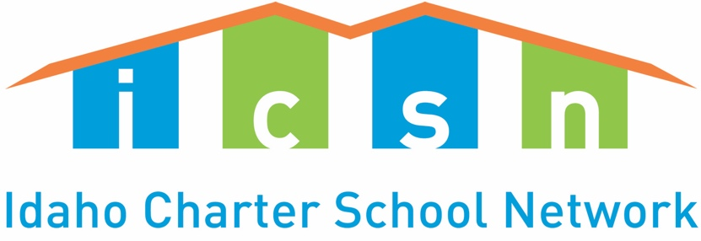

House Bill 512 Fact Sheet

What Is HB512?
HB512 would provide Idaho Public Charter schools the voluntary option of utilizing a “weighted student lottery” should the charter school be overenrolled and required to administer a lottery for new student enrollments. Students who meet the following criteria could be given additional “weights” in the lottery:
- Students living at or below 185 percent of the federal poverty level.
- Students who are homeless or in foster care.
- Children with disabilities.
- Students with limited English proficiency.
- At-risk students.

Twenty-six states allow weighted lotteries, and at least 11 do so through statute. Idaho’s bill is modelled after Utah’s law.

Why Is HB512 Needed?
This is an “academic achievement gap closing” bill. Idaho’s starkest educational challenge is its educational achievement gaps. In 2019, according to NAEP Data (The Nation’s Report Card) Idaho students who lived below the federal poverty level had an average score in 8th grade reading that was 21 points lower than that for students who were not in poverty. This performance gap has almost doubled since 2002. In 8th grade math the results are even worse. In 2019, Idaho students who lived below the federal poverty level had an average score that was 25 points lower than that for students who were not in poverty. This performance gap has also widened since 2000.

Similar gaps persist for students who are homeless or in foster care, students with disabilities and for students who are at-risk and or limited English proficient.

To close our achievement gaps, we must look for ways to increase opportunities for struggling students to attend our state’s higher performing schools. Idaho students living in poverty who attend a public charter school do better in both English Language Arts and in math on the ISAT than their peers in traditional public schools. This is true in both proficiency and growth. See Table 1 on the following page.

Table 1: Performance of Students in Poverty by All State Charter Students & All Students Statewide (2018-19)
 | All Public Charters | All State Public Schools
Share Proficient ELA | 50% | 42%
Share Proficient Math | 39% | 32%
Share Making Adequate Growth ELA | 62% | 56%
Share Making Adequate Growth Math | 49% | 44%
Data come from Idaho State Board of Education

HB512 Helps Idaho Meet Its ESSA Plan
Idaho’s ESSA plan, as approved by the U.S. Department of Education in 2018, sets several ambitious five-year goals including:
- Decreasing the number of students who are not proficient at English language arts and math by one third.
- Decreasing the number of students who are not making progress toward English language proficiency by one third.

The performance of Idaho’s public charter schools is helping move the needle towards meeting Idaho’s ESSA goals. HB512 will allow charters that are ready, willing and able to serve more students who need better learning options to meet or exceed academic proficiency and growth.

HB512 Is Important for Helping Idaho Successfully Implement its federal “Communities of Excellence” Charter School Program Grant
In 2018, Idaho received a competitive Charter School Program (CSP) Grant from the U.S. Department of Education for $17 million. It was subsequently increased to $22.1 million in 2019. Idaho’s “Communities of Excellence” Consortium includes: Bluum, J.A. and Kathryn Albertson Family Foundation, Idaho State Board of Education and Idaho Public Charter School Commission.

Idaho’s CSP Grant Objectives included: “Increasing the number of quality charter school seats by 8,200 students, especially for our most educationally disadvantaged and rural students, through start-up, replication and expansion. So far, this grant has provided $10,383,224 to 11 public charter schools across the state of Idaho to launch or expand 5,270 new school seats.

HB512 Helps Public Charter Schools Stay True to Their Missions
Idaho’s Public Charter Schools deliver results in part because they are mission driven schools. Public Charter Schools are required under state law to have a Performance Certificate that defines clearly the school mission. Elevate Academy in Caldwell, for example, has the following mission: “Elevate Academy is a 6th-12th learning environment committed to serving at-risk students. Through purposeful instruction students will take responsibility for leading their own lives and studying a career track that may include vocational and college paths or a combination thereof. By owning their educational pathways, students will become contributing members of their community and local economy upon graduation.”
For more information contact:
Terry Ryan, Board Chair
Idaho Charter School Network
Cell: 202-341-4575

https://www.sde.idaho.gov/assessment/naep/

