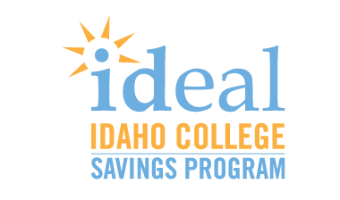
REPORT:
State of College Financial Preparedness in Idaho

Attitudes and Behavior of Idaho Families

Background

IDeal – Idaho College Savings Program is a state sponsored, tax advantaged savings plan that helps families save for the cost of college. With the rising costs of college, developing a savings plan can be the first and most important step in helping families finance a college education.

Financial preparedness is among the chief factors influencing whether students choose to go on to higher education. A 2017 report by the University of Idaho’s McClure Center for Public Policy cites evidence that Idaho’s effort to raise our state’s college-going rate must emphasize reducing financial barriers.

And according to KTVB, “The Idaho Center for Fiscal Policy, a non-profit, non-partisan organization, calls the growing debt load for many students combined with steeply rising tuition and fees, and higher barriers to attending college for middle and low-income Idahoans a threat to Idaho's economy.”

Empowering students to go on to higher education is a crucial effort, given the economic demand for college graduates and the fact that college graduates earn an average of $17,500 per year more than high school graduates.

In addition to the practical effect of potentially helping reduce out-of-pocket expenditures and dependence on student loans, studies by Washington University show that whether a family has saved any amount for college greatly impacts (up to seven times) a child’s likelihood of going on and finishing their higher education.

With this report, IDeal—Idaho’s 529 College Savings Program sheds light on the savings behaviors of Idahoans who are preparing for the costs of higher education and where more work can be done to promote college financial preparedness.

“Widespread reliance on student loans cannot be the status quo if we wish to sustain the work being done across our state right now to improve college-going rates. High loan balances can stall economic adulthood and lead to missed financial opportunities. Idaho’s work to fund more scholarships is a meaningful and necessary first step. Long term, families also need a financial tool over which they have more direct control, such as the state’s 529 college savings program.”

–Christine Stoll, Executive Director, IDeal—Idaho 529 College Savings Program

Data reported in this report compares 9/30/2016 to 9/30/2017.
Contents

Commentary | 3
Key Findings: Statewide | 4
Regional Comparisons | 5
North Idaho Findings | 6
Southwest Idaho Findings | 6
Central Idaho Findings | 6
Eastern Idaho Findings | 6
Local Case Study | 7

Commentary
This report provides a benchmark for the coming years, and intends to show local communities both good news and room for improvement. As IDeal continues our work, we thank those who have supported the Program. We ask that community officials and leaders throughout our state take the opportunity to get the word out to Idaho families about this powerful tool for overcoming the financial barriers to higher education.

Our key takeaways include:
- There is a large appetite among Idahoans for ways to address the financial barriers to college. More work can be done to make families aware of college savings plans like IDeal, and their advantages.
- Current market performance has demonstrated the potential powerful advantages of having an investment account dedicated to helping pay for higher education.
- Counties that saw a decrease in college savings account ownership can and should consider renewed efforts to help families start saving for college, but should also consider that a decrease in account ownership may mean that several families used their college savings accounts—which is a cause for celebration in itself.

How Idaho Families and Leaders
Can Help Promote College Savings

The incremental increase among Idahoans in saving for college demonstrated in this report is the result of work by not only IDeal—Idaho 529 College Savings Program, but also the many community stakeholders, educators, and organizations that have helped promote the Program to Idaho families.

As IDeal continues our work, we thank those who have supported the program, and we ask that even more community officials and leaders take the opportunity to spread the word.

- Give the gift of college savings:
The holidays or significant life events could be the perfect time to open or add to a college savings account for a family member or a friend.
- Ask for a 529 gift:
If you have a college savings account for a child, ask friends and family to contribute to it in lieu of (or along with) toys.

- Host an information event:
Invite an IDeal—Idaho 529 College Savings Program representative to speak at your school or workplace.
- Offer payroll direct deposit:
IDeal—Idaho 529 College Savings accounts are a great way to offer a zero-cost voluntary benefit to employees.

Learn More at IDsaves.org
Key Findings: Statewide

More than 14,000 Idahoans are currently saving for over 27,000 students with IDeal—Idaho 529 College Savings Program.

Idahoans have $47 million more in IDeal college savings accounts than they did this time last year. This increase can be attributed in great part to market performance and conditions. IDeal allows families to invest as a way to potentially save more money for higher education expenses, as well as receive Idaho state tax benefits. Savers have an average of nearly $14,000 in their accounts.

Saving for college is on the rise among Idahoans. Over the past year, the total number of IDeal college savings accounts held by Idahoans grew by 3%.*

Idahoans used $28.5 million saved through IDeal toward higher education over the past year.

Approximately 800 more Idaho students have someone saving for their future college costs today than this time last year.*

*These are net numbers. Over the same period, over 1,200 Idahoans also used their college savings and closed their accounts.
Statewide Beliefs about College Financial Preparedness

In 2017, IDeal—Idaho College Savings Program surveyed over 500 Idahoans to understand attitudes toward and awareness of college savings. All participants were parents or grandparents of a child aged 0-18. The survey’s margin of error is +/- 4%.

Findings from the survey included the following:

- Idaho parents care about helping their children pay for higher education. Only three percent of surveyed parents who do not have a college savings plan indicated that they don’t believe it’s their responsibility to help pay for college.
- Idahoans don’t think of college savings plans first when they think about how to pay for college. College savings plans rank behind regular savings accounts, grants and scholarships, and federal and private student loans in terms of statewide awareness of vehicles to finance higher education.
- 8 in 10 Idaho parents and grandparents are not aware of the available state tax deduction for contributions to Idaho’s 529 program. Idaho taxpayers may deduct up to $6,000 (single filers) or $12,000 (married filing jointly) for contributions to any IDeal—Idaho 529 College Savings Program accounts.

There is a clear appetite among Idaho families for tools to help address college costs—and therefore more work to be done to spread the word about IDeal.
Regional Comparisons
Regions | Total Accounts Per Capita | Beneficiary Accounts: Year Over Year Growth | Account Owners: Year Over Year Growth | Account withdrawals to pay for higher education
North | 1.3% | +2.4%  (+91) | +1.8%  (+36) | $3.6 million
East | 0.9% | +4.5%  (+141) | +1%  (+141) | $2.8 million
Southwest | 2.8% | +2.8%  (+512) | +1.6%  (+512) | $19.7 million
Central | 1 % | +3.5%  (+65) | +1.4%  (+65) | $2.4 million

Southwest Idaho far surpasses other regions in the state in terms of account ownership.

However, we see promising trends in other parts of the state:

- Regionally, eastern Idaho led the state in year-over-year growth in beneficiary accounts held.
- Regionally, north Idaho led the state in year-over-year account owner growth.

The growth reflected in eastern and north Idaho particularly—and across all the state’s regions—reflect a concerted effort on part of IDeal, its partner organizations, and community stakeholders to spread the word about college savings to every corner of the state.

An Account Owner may have more than one beneficiary.

North Idaho Findings

- North Idaho families have $5.9 million more in their IDeal college savings accounts than they did a year prior.
- Idaho County led North Idaho in growth in account ownership over the past year.
- Of counties with a population over 25,000, Bonner and Nez Perce led the entire state in growth in college savings ownership over the past year.
- Kootenai County residents used over $1.9 million through IDeal toward higher education over the past year.

 | Account Owner % Change | Approximate Change in Savings | Account withdrawals to pay for higher education
Idaho County | 9%  (+4) | $159,000 | $48,000
Bonner County | 4.9%  (+10) | $454,000 | $423,000
Nez Perce County | 3.7%  (+7) | $405,000 | $333,000
Kootenai County | 1.3%  (14) | $3.5 million | $1.9 million
Latah County | 0.8%  (3) | $1 million | $777,000
Shoshone County | 0 | $21,000 | $43,000
Benewah County | 0 | $17,000 | $20,000
Lewis County | 0 | ($2,600) | $13,000
Clearwater County | -2.9%  (-1) | $134,000 | $20,000
Boundary County | -3.5%  (-1) | $153,000 | $31,000
North Idaho Region | +1.8%  (36) | +$5.8 million | $3.6 million

Note: Reduction in account ownership or savings may be a result of account owners using funds for qualified higher education expenses or closing the accounts. Numbers reported here are rounded. Data reported in this report compares 9/30/2016 to 9/30/2017.
North Idaho Case Study: Michael Nail
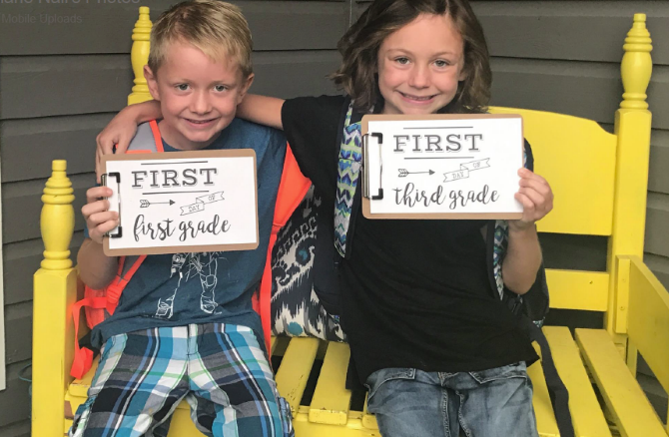
For Christmas this year, Michael Nail’s parents won’t be giving his children, Emmie and Eli, toys. Instead, the grandparents will be contributing to the children’s IDeal—Idaho 529 College Savings Plan accounts.
Emmie, age eight, and Eli, age six, may not yet appreciate the gift of college savings. “They don’t like it” says Michael. But that’s okay with him, because, he says, “Having the kids be able to start with a clean slate after college is really important to my wife and me.” Michael’s parents don’t mind either. “They’re pretty practical folks,” Michael notes, “so they’d rather put the money toward college than a toy.”
Michael started saving for Emmie and Eli about three years ago. He and his wife both had help from their own parents financing their higher education, and the couple wanted to be able to do the same for their own children. As an accountant, Michael sees firsthand how student loans can impact a person’s personal finances long after they graduate from college. “My younger clients—I tell them that I see people my age still paying for their education twenty years later.”
Once Michael opened accounts for his children, he says it was easy to convince his parents to contribute to the children’s college savings accounts on special occasions. “I just said if you want to put money into college savings accounts instead of buying a toy that’s going to break in a few months, this is an option.” Michael’s parents use IDeal’s online gifting feature.
By contributing to Emmie and Eli’s college savings accounts, Michael’s parents are also giving him a gift. “It’s money I won’t have to spend later,” he states, but it’s also helping him build peace-of-mind about his children’s futures. “It’s always easier to start saving now, versus putting your head in the sand and waiting.”

Southwest Idaho Findings

- Southwest Idaho families have $35 million more in their IDeal college savings accounts than they did a year prior.
- Boise County led southwest Idaho in growth in account ownership.
- Ada County residents used $17.5 million through IDeal toward higher education over the past year.

 | Account Owner % Change | Approximate Change in Savings | Account withdrawals to pay for higher education
Boise | 5.7%  (+2) | $82,000 | $72,000
Canyon | 3.1%  (+30) | $1.7 million | $1.5 million
Adams | 2.9%  (+1) | $122,000 | $62,000
Payette | 2.2%  (+2) | $503,000 | $92,000
Ada | 1.5%  (+122) | $31 million | $17.5 million
Owyhee | 0 | $30,000 | $22,000
Valley | 0 | $724,000 | $212,000
Gem | -1.5%  (-1) | $183,000 | $117,000
Washington | -2.9%  (-1) | ($13,000) | $61,000
Elmore | -6.7%  (-4) | $12,000 | $94,000
Southwest Idaho Region | 1.54% | $35 million | $19.7 million

Note: Reduction in account ownership or savings may be a result of account owners using funds for qualified higher education expenses or closing the accounts. Numbers reported here are rounded. Data reported in this report compares 9/30/2016 to 9/30/2017.

Southwest Idaho Case Study: Robin Rausch

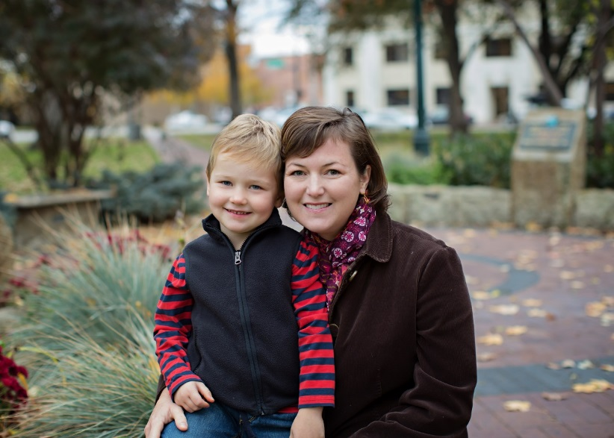
Robin Kelley Rausch, of Boise is a mother of two children—ages seven and four—who tries to carry on the college-going culture from the one she grew up with to her own family now. A Buhl native, Rausch learned early in life about the value of higher education from her parents. “My parents would say, ‘Money comes and goes. Health can be unpredictable. But once you earn an education, that’s yours. Nobody can take your education away from you.’”

Rausch has had IDeal accounts for both of her children since they were infants, and contributes to the account monthly with automatic deductions. Robin’s parents help contribute to the account, and the children even chip in sometimes. “Last year my kids each received $100 for Christmas from a grandparent, with no strings attached. They both chose to invest in their college savings accounts. Going to college is something that we talk about as a family and they clearly understand that value,” she says.

Education represents individual empowerment for Rausch’s own children. “My son is four, and I told him, ‘You are so close to being able to read and write your own stories.’ He got so excited that he is now writing miscellaneous letters and numbers on a notepad and says that he is writing a book.”

Rausch has some advice for parents who want to inspire their own children to go on to higher education: “I think the message needs to come from both parents and other family members. The message is a common foundation of the family culture. Beyond talking about it, both parents need to be on board with putting that money away now.”

Central Idaho Findings

- Central Idaho families have $3.2 million more in their IDeal college savings accounts than they did a year prior.
- Lincoln County led central Idaho in growth in account ownership.
- Blaine County residents used $1.5 million through IDeal toward higher education over the past year.

 | Account Owner % Change | Approximate Change in Savings | Account withdrawals to pay for higher education
Lincoln | 10.00%  (+1) | $29,000 | $18,000
Jerome | 3.33%  (+2) | $186,000 | $108,000
Minidoka | 3.33%  (+1) | $55,000 | $44,000
Twin Falls | 2.32%  (+8) | $1 million | $615,000
Blaine | 1.34%  (+5) | $1.4 million | $1.5 million
Cassia | -1.52%  (-1) | $274,000 | $57,000
Gooding | -5.71%  (-2) | $162,000 | $38,000
Camas | -25.00%  (-1) | ($5,000) | $2,000
Central Region | 1.41%  (+13) | $3.2 million | $2.4 million

Note: Reduction in account ownership or savings may be a result of account owners using funds for qualified higher education expenses or closing the accounts. Numbers reported here are rounded. Data reported in this report compares 9/30/2016 to 9/30/2017.
Central Idaho Case Study: Tamara Satterwhite

Tamara Satterwhite, of Twin Falls, loves collecting Idaho wildflowers. Someday, she might be able to make a career of her hobby. “I want to go into plant sciences. I really like plants, collecting them, categorizing them, and learning their names,” she says. Thanks to her IDeal—Idaho 529 College Savings Account, that dream has a good chance of becoming a reality.

Tamara’s mother has been saving for college with IDeal—Idaho College Savings Program since Tamara and her sister, Miranda, were young children. “She put money aside every paycheck,” notes Tamara.

Tamara started her higher education journey at College of Southern Idaho. When her first tuition payment came due for $2,000, she turned to her IDeal account to make the payment. “It made my payments to CSI only $100 a month,” she says.

At twenty years old, Tamara now manages her own IDeal account, and even contributes part of her paycheck to the account for post-graduate schooling. She’s an avid evangelist for the program: she urged her boyfriend to start his own 529 account, and tells her grandmother to contribute to the account in lieu of monetary gifts.

Tamara got a big break when she was hired by an employer that offers tuition reimbursement through Arizona State University's online program. She transferred to the university and uses her remaining IDeal funds help pay for books. She expects to finish a Bachelor of Science in Biochemistry two years from now, debt-free. She credits her mother, Angela Hubbard, for the sacrifices she made to provide her with an easier path to higher education. In fact, Angela just finished a bachelor’s degree last year. “It’s important to her that we have opportunities she didn’t have until later in life,” says Tamara.

Thanks to her mother’s dedication to saving, one of those opportunities Tamara gets to capitalize on is the ability to travel. “The only reason I’ve been able to do that is because I had IDeal. Going to school is important, but living your life is also important,” she says.
Eastern Idaho Findings

- Eastern Idaho families have $3.7 million more in their IDeal college savings accounts than they did a year prior.
- Custer County led Eastern Idaho in growth in account ownership.
- Bonneville County residents used $1.6 million through IDeal toward higher education over the past year.

 | Account Owner % Change | Approximate Change in Savings | Account withdrawals to pay for higher education
Custer | 21.4%  (+3) | $100,000 | $20,000
Fremont | 7.1%  (+1) | $103,000 | $1,000
Teton | 3.9%  (+3) | $219,000 | $139,000
Bingham | 1.9%  (+2) | $234,000 | $170,000
Bannock | 1.8%  (+7) | $1.1 million | $703,000
Bonneville | 0.3%  (+2) | $1.5 million | $1.6 million
Madison | 0 | $195,000 | $46,000
Jefferson | 0 | $109,000 | $41,000
Franklin | 0 | $10,000 | $28,000
Lemhi | 0 | $125,000 | $24,000
Power | 0 | $1,700 | $19,000
Bear Lake | 0 | $7,500 | $5,700
Oneida | 0 | $34 | $0
Clark | 0 | $1,400 | $0
Caribou | -4.4%  (-1) | $36,000 | $21,500
Butte | -33. 3%  (-2) | ($4,000) | $6,000
Eastern Idaho Region | 1.5% | $3.7 million | $2.8 million
Note: Reduction in account ownership or savings may be a result of account owners using funds for qualified higher education expenses or closing the accounts. Numbers reported here are rounded. Data reported in this report compares 9/30/2016 to 9/30/2017.

Conclusion

The incremental increase among Idahoans in saving for college demonstrated in this report is the result of work by not only IDeal—Idaho 529 College Savings Program, but also the many community stakeholders, educators, and organizations that have helped promote the Program to Idaho families.

This report provides a benchmark for the coming years, and intends to show local communities both good news and room for improvement. As IDeal continues our work, we thank those who have supported the Program. We ask that community officials and leaders throughout our state take the opportunity to get the word out to Idaho families about this powerful tool for overcoming the financial barriers to higher education. It only takes $25to start saving now. Learn more at idsaves.org

The Economist, “Is College Worth It?” https://www.economist.com/news/united-states/21600131-too-many-degrees-are-waste-money-return-higher-education-would-be-much-better
https://source.wustl.edu/2011/04/kids-with-savings-accounts-in-their-name-six-times-more-likely-to-attend-college/ https://csd.wustl.edu/publications/documents/rpb09-29.pdf About IDeal ─ Idaho College Savings Program IDeal is located within State Treasurer’s office and is administered by the Idaho College Savings Program Board. Ascensus Broker Dealer Services, Inc. serves as Program Manager. For more information, about IDeal, contact Christine Stoll at 208-332-2935, cstoll@idsaves.idaho.gov, or visit www.idsaves.org. Please add the following disclosure regarding the testimonials. If any of these folks are paid more that $100, we will have to state that it's a paid testimonial also. These testimonials are not representative of the experience of other customers and are no guarantee of future performance or success of the funds in the 529 accounts. For more information about the Idaho College Savings Program (IDeal), call 866-433-2533 or visit www.idsaves.org to obtain a Disclosure Statement. The Disclosure Statement discusses investment objectives, risks, charges, expenses, and other important information. Because investing in IDeal is an important decision for you and your family, you should read and consider the Disclosure Statement carefully before investing. Ascensus Broker Dealer Services, Inc. (ABD) is Distributor of IDeal. If you are not an Idaho taxpayer, consider before investing whether your or the beneficiary’s home state offers any state tax or other state benefits such as financial aid, scholarship funds, and protection from creditors that are only available for investments in such state’s qualified tuition program. IDeal is administered by the Idaho College Savings Program Board (Board). ABD, the program manager, and its affiliates, have overall responsibility for the day-to-day operations, including investment advisory and recordkeeping and administrative services. The Vanguard Group, Inc. (Vanguard) serves as Investment Manager for IDeal. Sallie Mae Bank serves as the Savings Portfolio Manager for IDeal. IDeal's Portfolios invest in either: (i) mutual funds offered or managed by Vanguard; or (ii) an FDIC-insured omnibus savings account held in trust by the Board at Sallie Mae Bank. Except for the Savings Portfolio, investments in IDeal are not insured by the FDIC. Units of the Portfolios are municipal securities and the value of units will vary with market conditions. Investment returns will vary depending upon the performance of the Portfolios you choose. Except to the extent of FDIC insurance available for the Savings Portfolio, you could lose all or a portion of your money by investing in IDeal, depending on market conditions. Account Owners assume all investment risks as well as responsibility for any federal and state tax consequences. Not FDIC-Insured (except for the Savings Portfolio). No Bank, State or Federal Guarantee. May Lose Value.

