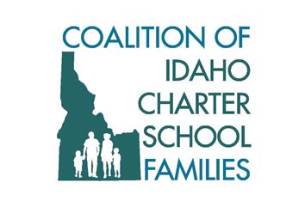
Press Corps

If you are covering recent comments from Idaho State Board of Education President Don Soltman regarding Idaho Virtual Academy, please consider using the following statement from The Coalition of Idaho Charter School Families, a parent-led coalition that advocates for school choice, including virtual schools.

"Every Idaho family deserves options in education, and that includes the virtual school option. Many families and students who choose a virtual education have not been well-served by previous schools, and sometimes have fallen behind. Other students choose this option in order to pursue dreams of competing in the olympics, to address a serious illness or medical emergency, and some choose this option to escape bullying. Whatever their situation, the virtual option provides students the opportunity to continue their education in an environment that works best for them and their needs.

High mobility rates of students at schools like Idaho Virtual Academy mean flawed and unreliable graduation rates should never be used as a reason to close a school and take away a critical school choice option from Idaho families. Moreover, Idaho Virtual Academy serves many high risk students yet is the lowest funded public school in the state.

President Soltman is playing the blame game and overlooking the facts and circumstances of these students. It's irresponsible and threatens what every parent and students deserves: school choice."

Sent to you by the
Coalition of Idaho Charter School Families
Tom LeClaire President
Contact Person Jane Wittmeyer 208-859-9656

