

May 19, 2015

8:00am - 8:00pm

Ladies Club Hall

Voter Registration Available On Site

If not already registered, please bring government-issued ID and proof of residency ( i.e. power bill, lease agreement, etc…).

Whom Do I Contact With Questions?

* Dennis Chesnut [chesnutd@hsbschools.org](mailto:chesnutd@hsbschools.org)
* Cora Larson [larsonc@hsbschools.org](mailto:larsonc@hsbschools.org)
* Your school board representative

How Would The Money Be Spent?

* Maintain current staffing
* Increase elective offerings such as foreign languages, music/band, physical education, dual credit courses, etc…
* Purchase PTE equipment (welding equipment, power tools, supplies, materials, etc…)
* Maintain/repair buildings and facilities
* Upgrade curriculum and textbooks
* Technology and technology upgrades
* Improve science equipment and supplies
* Fully fund athletics and other extra-curricular activities

What Would It Cost?

**$301.54 per $100,000** of taxable value

The levy request is for up to $300,000/year for two years.

Primary dwelling homes may receive a 50% homeowner’s exemption. $226.16 is how much a homeowner with a home valued at $150,000 will pay with a 50% homeowner’s exemption.

These figures can be verified by contacting the Boise County Clerk’s Office.

Will My Taxes Increase?

Your tax rate will NOT increase

This is a replacement of the current supplemental levy which expires on June 30, 2015. In fact, the overall tax levy rate which includes tort, construction bond, and supplemental levy will decrease slightly.

Will Levy Money Be Used For Raises?

No

The levy money will not be used for any pay increases, but will be used to keep and improve current programs. If there is any increase in teacher salaries, it will be the result of an increase in state funding for salaries and benefits.

What If The Levy Fails?

Spending Cuts

While the district will do everything possible to minimize the impact of spending cuts on our students, a negative impact is likely unavoidable.

Anticipated cuts could include:

* Eliminating certified teachers and classified staff
* Preschool eliminated
* Kindergarten reduced to ½ day
* Drastic reduction or elimination of district-funded athletics

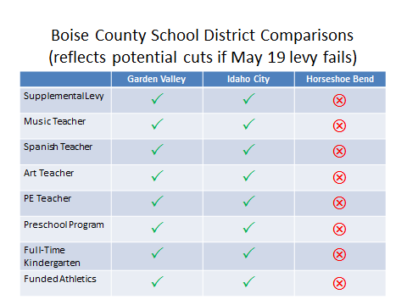

Why Do We Need A Levy?

Decreased State Funding

State funding for schools has decreased steadily since 2008, forcing nearly every school district in Idaho to ask their patrons to support supplemental levies.

Due to the economic downturn and legislative actions, the burden of adequately funding schools has fallen more and more on the local taxpayers.

In 2008, state support for our school was $2.13 million. In 2014, state support for our school was $1.63 million. While it appears state funding will increase in 2015, the increase in funding will not be nearly enough to restore our school to 2008 funding levels.

Formatting Text Boxes

You can change the look of linked text boxes by using color, shading, borders, and other formatting. Select the text box you want to format and then double click its border to open the Format Text Box dialog box. If you want to change the color or borders on a text box, choose the Colors and Lines tab. To change the size, scale, or rotation, click the Size tab. To change the position of the text box on the page, click the Position Tab. If you have other text surrounding the text box, and want to change the way the text wraps

around it, click the Wrapping tab. If you want to format all the text boxes in an article, you must format them individually - the formatting on one text box will not apply to the others in the sequence.

Using Linked Text for Parallel Articles

You can use linked text boxes to flow text in parallel “columns” from page to page. This method gives different results than using the Column command on the Format menu, which causes text in column 1 to flow or “snake” to column 2 on the same page. By using linked text boxes, you can instead have text from column 1 flow to column 1 on the next page. The text beside it in column 2 can flow to column 2 on the next page, parallel to column 1. This technique is useful if you need to group two similar articles, for instance, an article translated in English on the left and the same article translated in French on the right.

To flow text in parallel, display paragraph marks in your document. Click at the top of the page where you want the side-by-side columns to start, and press Enter twice. Click in the first paragraph mark on the page. On the Insert menu, click Text Box and drag on the page where you want the first column. Click Text Box again and then click and drag where you want the second column. Click in the last paragraph mark on the page, and press Ctrl + Enter to create a page break.

Repeat the process for each page that will contain side-by-side columns in your document and then return to the first text box you created. Click the text box on the left once to select it. Click your right mouse button and then click Create Text Box Link. The pointer becomes a pitcher. Click the text box on the left side of the second page to create a link. Create links for all text boxes within the same article on the left side of the document. Repeat the process for every text box in the right chain or article.

Pressing Enter twice at the top of each page will create an extra empty paragraph. This blank paragraph is useful if you want to insert text or graphics outside of the text boxes. You can delete the extra blank paragraph if you don't need it.

Copying linked text boxes

You can copy an article or a chain of text boxes that are linked together, to another document or to another location in the same document. To copy linked text boxes and the text they contain, you must copy all the linked text boxes in an article. Select the first text box in an article. Hold down Shift, and click each additional text boxes you want to copy. On the Edit menu, click Copy. Click where you want to copy the text boxes and then click Paste.

To copy some of the text from an article, select the text you want to copy from the article and then copy it. Do not select the text box. You can paste text you’ve copied directly into your document, into another location within the same article, or into another article.❖

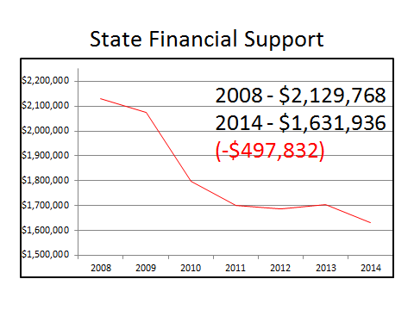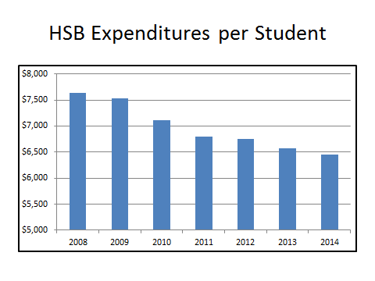

HORSESHOE BEND SCHOOLS SUPPLEMENTAL LEVY

MAY 19, 2015





May 19, 2015

8:00am - 8:00pm

Ladies Club Hall

Voter Registration Available On Site

If not already registered, please bring government-issued ID and proof of residency ( i.e. power bill, lease agreement, etc…).