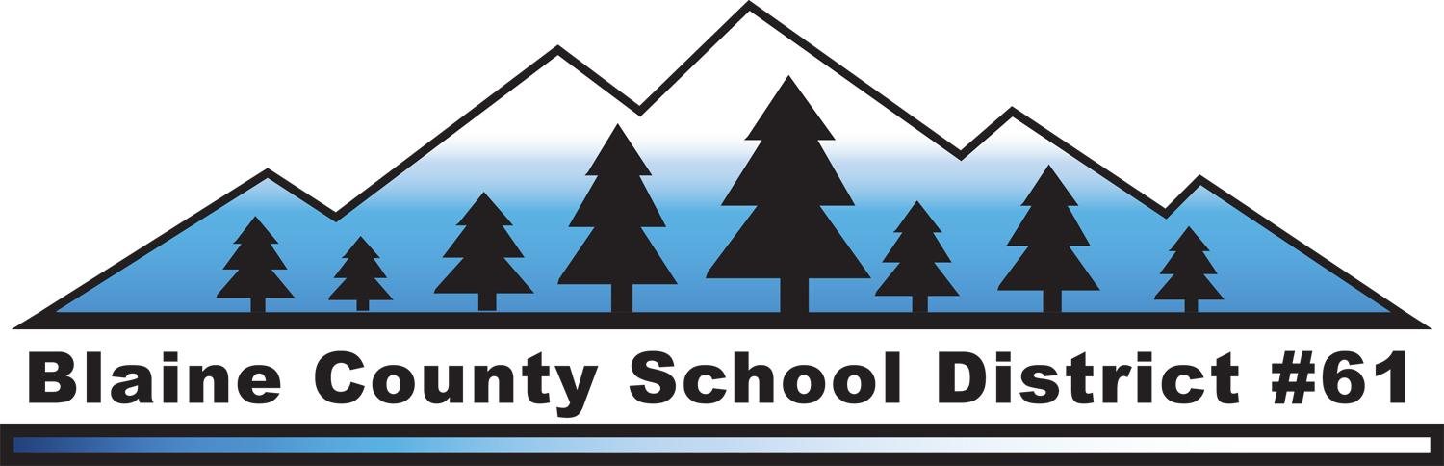FOR IMMEDIATE RELEASE
Contact: Heather Crocker
Communications Director
Blaine County School District #61
208-578-5005
HCrocker@blaineschools.org

April 17, 2014

Public Invited to Superintendent Candidate Forums

The public is invited to hear from the final two candidates for the Superintendent position of the Blaine County School District on Tuesday, April 22 at 6:00 p.m. at the Distance Learning Lab at Wood River High School. Wood River High School is located at 1250 Fox Acres Road, Hailey, ID.

This public forum will be moderated by the executive search firm Ray and Associates. Each candidate will have a separate time allotted during the forum to introduce themselves and answer several questions. The public may submit questions for the candidates at the beginning of the forum or at www.blaineschools.org. Look for the question box on the lower left corner of the website or go to the Superintendent Search page. Questions will be selected based on the themes from the focus groups held in February. Neither candidate will know the questions ahead of time. The same set of questions will be used for both candidates. The public will have an opportunity to complete a candidate feedback form at the end of each Q&A, which will be one factor in the Board’s final selection.

The two final candidates for the Superintendent position are:

Dr. GwenCarol Holmes is currently the Chief Academic Officer of Alexandria Public Schools in Alexandria, Virginia. Prior to her position at Alexandria Public Schools, Dr. Holmes was the Chief Operating Officer of the Success for All Foundation and assistant professor at Johns Hopkins School of Education. She attended Kansas State University and earned two master’s degrees and a doctorate of education in educational administration. Her father and uncle first brought her to Blaine County for a backpacking trip when she was a teenager and she has returned regularly ever since.

Dr. Richard Canfield is the Superintendent of Schools for Sandwich Public Schools in Cape Cod, Massachusetts. Prior to his position with Sandwich Public Schools, Dr. Canfield was Assistant Superintendent for the Monroe, Connecticut schools. He earned his doctorate at St. John’s University in Queens, NY, his masters degree from the University of Bridgeport and his bachelor’s degree from Springfield College, MA. Dr. Canfield and his wife own a home in Blaine County and have vacationed here since 1992.

For more information, including bio’s for each candidate, go to www.blaineschools.org and click on the Superintendent Search link.
####

